international symposium
Compliant Cyber–Defence
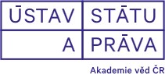
organised by
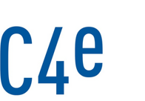Institute of Law and Technology, Faculty of Law, Masaryk University,
Institute of State and Law of the Czech Academy of Sciences and
Cybersecurity, Cybercrime and Critical Information Infrastructures Centre of Excellence

Programme:

9:00 – 9:30 check-in

9:30 – 11:00 Territoriality and Sovereignty
opening note by Dan Jerker B. Svantesson (Bond University)

11:00 – 11:15 coffee break

11:15 – 12:45 Use of Force
opening note by Anna-Maria Osula, (Tallinn University of Technology)

12:45 – 14:00 lunch break

14:00 – 15:30 Building Cyber – Capabilities
opening note by Radim Polčák (Masaryk University)

Date: 3 December 2018
Place: Institute of State and Law, Czech Academy of Science (Ústav státu a práva AV ČR),
Národní 18, Praha
Registration and administrative contact: Veronika Žolnerčíková (zolnercv@mail.muni.cz)

